How to Install Jenkins on CentOS 7
Jenkins is a popular open source CI (Continuous Integration) tool which is widely used for project development, deployment, and automation.
This article will guide you through the process of installing Jenkins on a CentOS 7 server instance. In order to facilitate visitors' access, Nginx will also be installed as the reverse proxy for Jenkins.

Prerequisites
Before proceeding, you must have:
- Deployed a CentOS 7 server instance from scratch.
- Logged into your machine as a non-root user with sudo privileges.

Step 1: Update your CentOS 7 system
One of the Linux system administrator's best practices is keeping a system up to date. Install the latest stable packages, then reboot.
sudo yum install epel-release
sudo yum update
sudo reboot
When the reboot finishes, login with the same sudo user.

Step 2: Install Java
Before you can install Jenkins, you need to setup a Java virtual machine on your system. Here, let's install the latest OpenJDK Runtime Environment 1.8.0 using YUM:
sudo yum install java-1.8.0-openjdk.x86_64 -y
After the installation, you can confirm it by running the following command:
java -version
This command will tell you about the Java runtime environment that you have installed:
openjdk version "1.8.0_91"
OpenJDK Runtime Environment (build 1.8.0_91-b14)
OpenJDK 64-Bit Server VM (build 25.91-b14, mixed mode)
In order to help Java-based applications locate the Java virtual machine properly, you need to set two environment variables: "JAVA_HOME" and "JRE_HOME".
sudo cp /etc/profile /etc/profile_backup
echo 'export JAVA_HOME=/usr/lib/jvm/jre-1.8.0-openjdk' | sudo tee -a /etc/profile
echo 'export JRE_HOME=/usr/lib/jvm/jre' | sudo tee -a /etc/profile source /etc/profile
Finally, you can print them for review:
echo $JAVA_HOME
echo $JRE_HOME

Step 3: Install Jenkins
Use the official YUM repo to install the latest stable version of Jenkins, which is 1.651.2 at the time of writing:
cd ~
sudo yum install wget -- Install the software wget
sudo wget -O /etc/yum.repos.d/jenkins.repo https://pkg.jenkins.io/redhat-stable/jenkins.repo
sudo rpm --import https://pkg.jenkins.io/redhat-stable/jenkins.io.key
sudo yum install jenkins
Start the Jenkins service and set it to run at boot time:
sudo systemctl start jenkins.service
sudo systemctl enable jenkins.service
In order to allow visitors access to Jenkins, you need to allow inbound traffic on port 8080:
sudo firewall-cmd --zone=public --permanent --add-port=8080/tcp
sudo firewall-cmd –reload
Note: -- If you are running Jenkins on AWS EC2 instance, then the above firewall configuration is not required. But make sure the firewall port is configured on Security Groups.
Now, test Jenkins by visiting the following address from your web browser:
http://<your-server-IP>:8080

If the page does not come up, try to disable the SELINUX.

Edit the selinux config file

# vi /etc/selinux/config

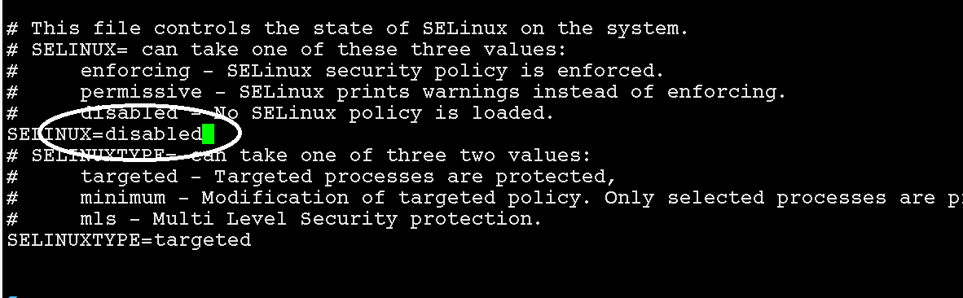

save the file -> press 'esc' and type ":wq" and enter.

REBOOT the linux machine and

$ reboot or init 0

Then try to access the jenkins web page.
http://<your-server-IP>:8080

